**Okasha Khan**

**Sp23-bse-057**

**Question 1**

**What is the destination port for the DNS query message? What is the source port of DNS response message?**

**SRC PORT**: 60913

**DST PORT:** 53

**Question 2**

**To what IP address is the DNS query message sent? Is this the IP address of your default local DNS server?**

**DNS Servers** . . . . . . . . . . . : 172.20.10.15

**SRC**: 172.20.43.51

**DNS**: 172.20.10.15

Yes both are same so the ip address is of local default DNS server

**Question 3**

**Examine the DNS query message. What “Type” of DNS query is it? Does the query message contain any “answers”?**

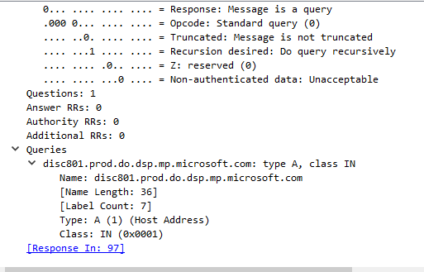

Answer is 0 and type is A

**Question 4**

**Examine the DNS response message. How many “answers” are provided? What do each of these answers contain?**

